Code File
For
Preserving Reinforcement
Learning Agent Intelligence

Submitted by:
Arpita Bhardwaj
Roll No: 25SCS1003001225

Under the supervision of:
Mr. Ramavath Ganesh



Department of Computer Science and Engineering
IILM University

November 2025

1.This code downloads a dataset from Kaggle and then unzips it so you can use it in Google Colab.

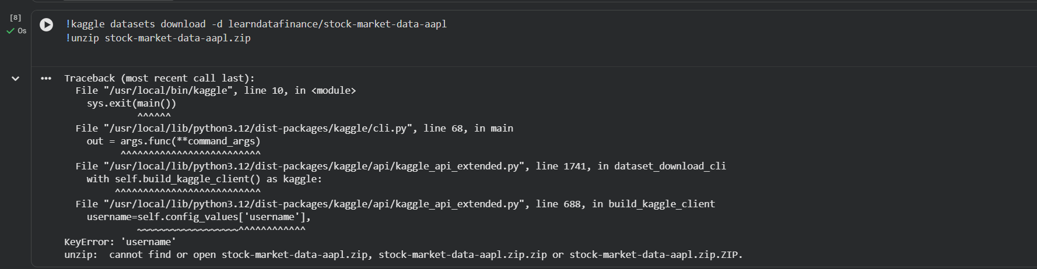

2.This code extracts (unzips) the uploaded ZIP file and shows the files inside it.

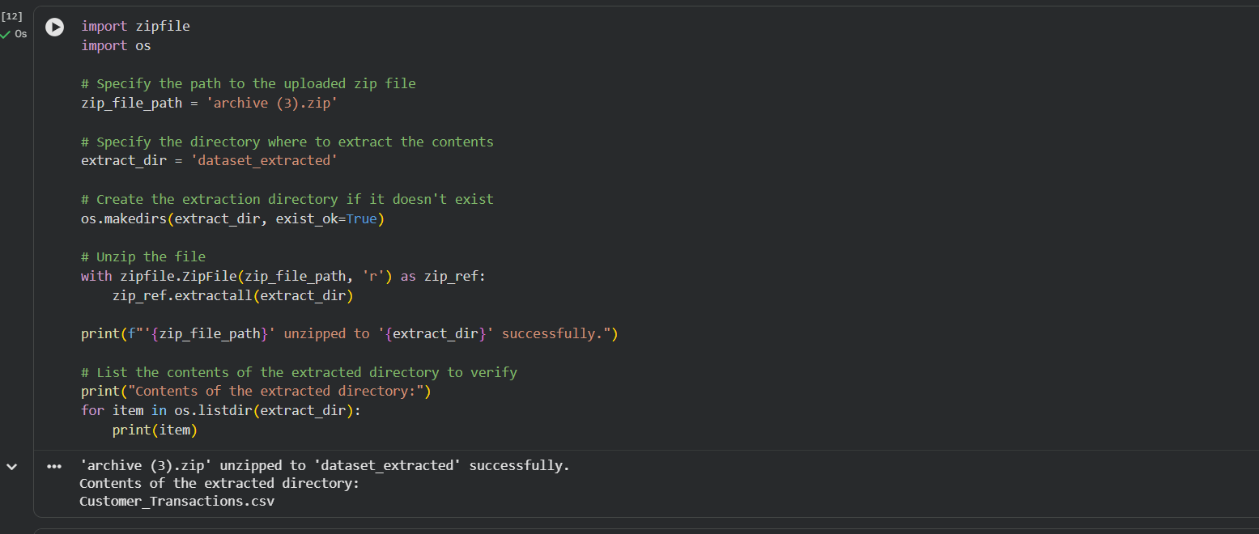

3. This code selects the target column and feature columns from the dataset and prints their names.

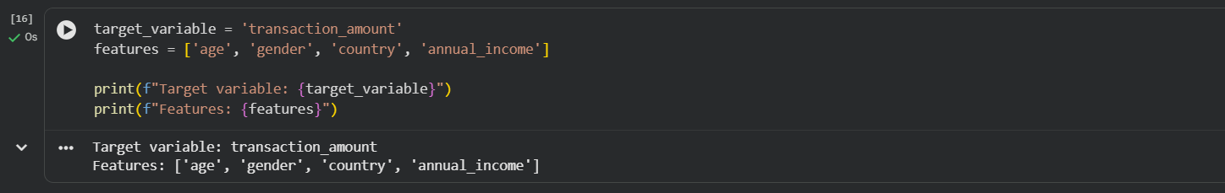

4. This code loads your dataset, selects valid feature and target columns, and automatically separates them into numerical and categorical features for model training.

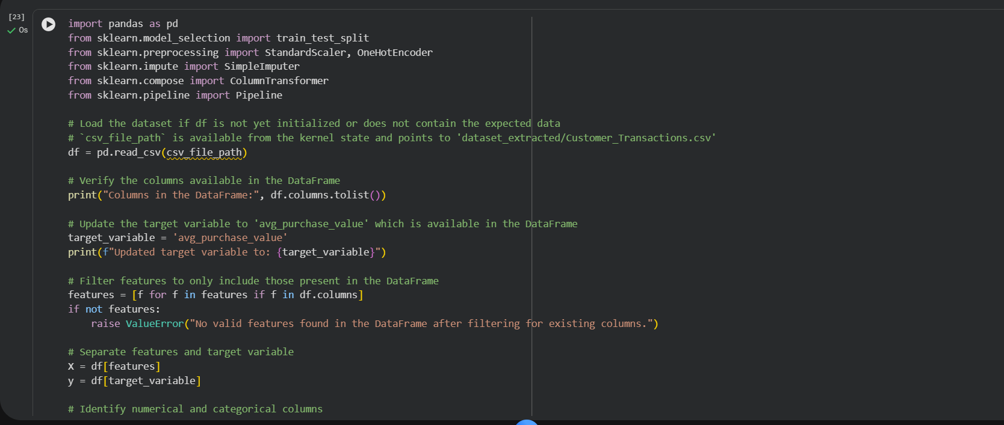
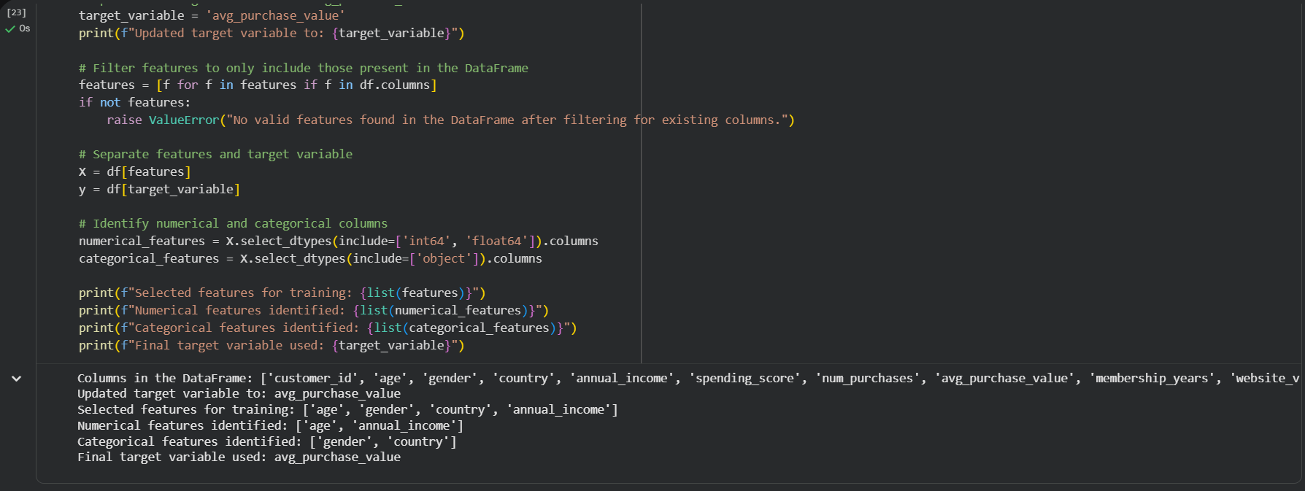

5. This code preprocesses the dataset (imputation, scaling, encoding) and then splits it into training and testing sets.

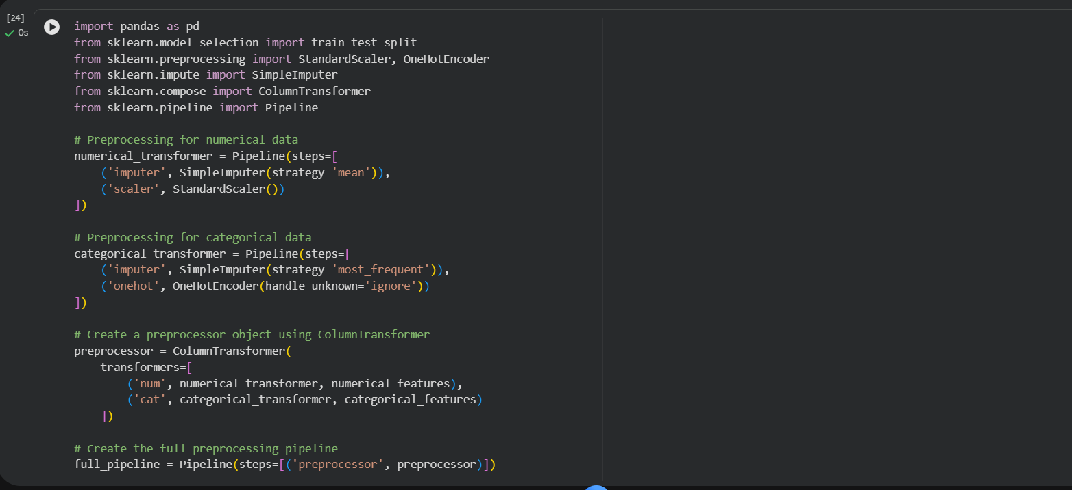
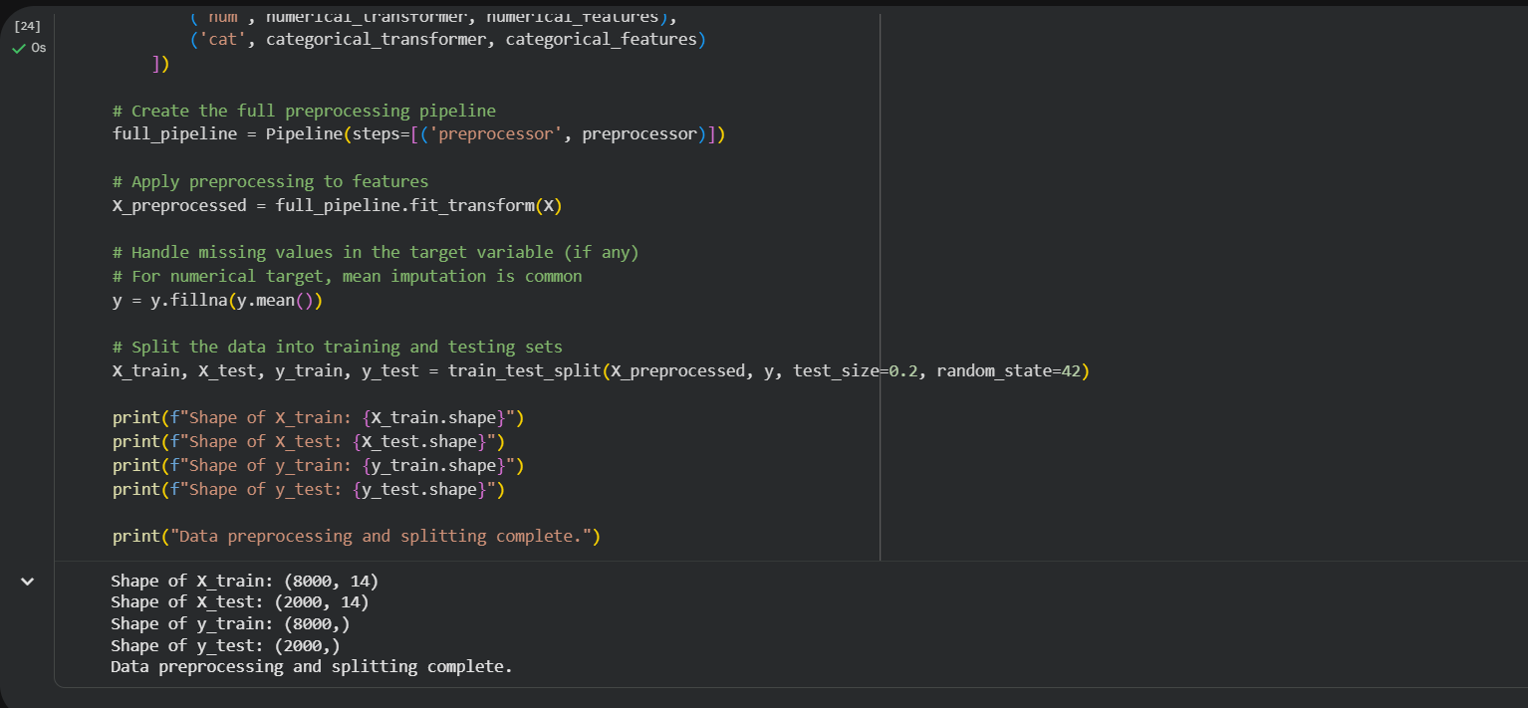

6. This code trains a Random Forest regression model using your preprocessed training data.

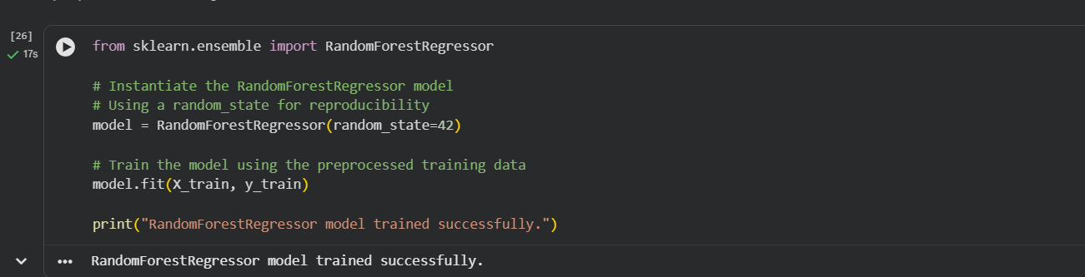

7. This code makes predictions using the trained model and calculates evaluation metrics (MAE, MSE, RMSE, R²) to measure its performance.

